✅ MYFUTURE+ LESSON PLAN
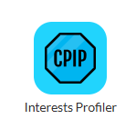
Exploring Career Interests through the Interest Profiler app
Section 1: Understanding and Developing Yourself
Duration: 45 Minutes
Programme: CPIP / Careers Education

🎯 Learning Outcomes
Students will:
- Understand the 8 Career Interest types.
- Identify their personal Top 3 Career Interests.
- Explore how interests link to jobs, apprenticeships and courses.
- Reflect on their learning from the Career Interests Profiler app.

🟢 Introduction (10 minutes)
Teacher Discussion:
Ask:
- What are interests?
- Are we always good at the things we’re interested in?
- Can interests change over time?
Explain:
Interests are things we enjoy. Often, they are things we are good at — e.g., sport, art, cooking. Sometimes we are interested in things we haven’t tried yet.
Your future career is often linked to your interests. Understanding them helps you make better career decisions.

🎡 The 8 Career Interest Types

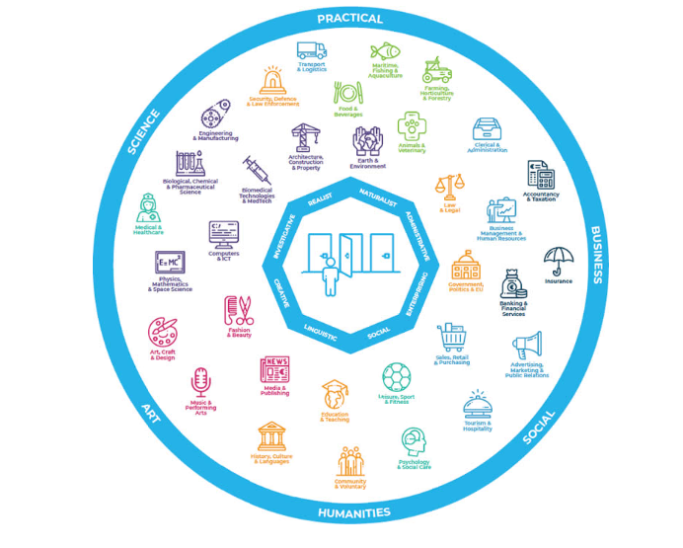
Explain that these interest types can help match students to:
- Career sectors
- Jobs (Career Matching)
- Apprenticeships
- CAO courses
- PLC courses
- Postgraduate study

🟡 Activity 1 – Guess Your Top 3 (10 mins)
Students will:
- Read the 8 interest descriptions.
- Predict their:
  - 1st strongest interest
  - 2nd strongest interest
  - 3rd strongest interest
Students record their answers on the worksheet (available in the app to download or print and circulate)

🔵 Activity 2 – Complete Career Interests Profiler (20 mins)
Steps:
- Open MyFuture+ Career Interest Profiler app
- Choose Young Adult or Adult version
- Read both statements carefully
- Choose the emoji that suits you best
At the end:
- Record your Top 3 interest types
- Explore matched jobs
- Explore matched courses (CAO, PLC etc)
Example:
- If your first type is Creative (C) → Careers such as art, design, music
- If Naturalist (N) → Careers involving nature, animals, environment

🟣 Activity 3 – Career Matching (10 mins)
Students match their Top 3 to:
- Jobs
- Apprenticeships
- CAO courses
- PLC courses
Discuss how interests link to wider career sectors.

🔴 Reflection Activity (10 mins)
Students answer:
- Were you surprised by your results? Why/why not?
- Do the suggested careers interest you?
- What did you learn about yourself?
- What is your next step?

✅ Success Outcomes
Students can:
- Name and explain their Top 3 interests.
- Match interests to appropriate careers and courses.
- Complete a written reflection on their results.

📊 Assessment for Learning
- Teacher observation
- Completed Top 3 worksheet
- Reflection responses

🎯 Universal Design for Learning
Support:
- Provide printed interest descriptions
- Allow discussion before writing
Extension:
- Research one matched career in detail
- Explore another MyFuture+ app

📚 Resources Needed
- Devices with internet
- MyFuture+ Profiler access
- Reflection worksheet

